***Pharmacy Information System***

*CSE221*: *Database systems*

Spring semester 2024

**Project Team**

|  |  |  |  |
| --- | --- | --- | --- |
| **Student ID** | **Student Name** | **Project Evaluation** | |
| **222100946** | ***Abdelrahman Atef Saad Osheba*** | Report |  |
| Presentation |  |
| Code |  |
| Total |  |
| **222100032** | ***Ahmed Ashraf Mohammed Abou El Ela*** | Report |  |
| Presentation |  |
| Code |  |
| Total |  |
| **222100195** | ***Adham Mohamed El Wakeel*** | Report |  |
| Presentation |  |
| Code |  |
| Total |  |
| **222100123** | ***Ahmed Alaa Eldin Mostafa*** | Report |  |
| Presentation |  |
| Code |  |
| Total |  |
| **222100933** | ***Abdelrhman Gamal Zakaria*** | Report |  |
| Presentation |  |
| Code |  |
| Total |  |
| **222101943** | ***Youssef Husseiny Fathy*** | Report |  |
| Presentation |  |
| Code |  |
| Total |  |
| **222101929** | ***Youssef Ahmed Ibrahim*** | Report |  |
| Presentation |  |
| Code |  |
| Total |  |
| **222101958** | ***Youssef Essam Moustafa Hanafi*** | Report |  |
| Presentation |  |
| Code |  |
| Total |  |
| **222100211** | ***Osama Adel Fawzy*** | Report |  |
| Presentation |  |
| Code |  |
| Total |  |

**Unter supervision of Professor:** Shaker El-Sappagh

2023-2024

**Abstract**

This report details the development of a Hospital Pharmacy Management System (HPMS). The system addresses the need for efficient medication management, inventory control, and patient data tracking in hospital pharmacies. It covers the business problem analysis, database design, backend implementation, frontend design, challenges encountered, solutions, and future directions.

**Introduction**

**The Business Problem Analysis**

The business problem analysis focuses on understanding the core challenges faced by hospital pharmacies. The main issues identified include:

Inefficient Medication Management: Manual processes often lead to errors in medication dispensing, delays, and increased workload for pharmacists.

Inventory Control: Inaccurate inventory tracking can result in stockouts or overstocking of medications, affecting patient care and increasing costs.

Patient Data Tracking: Manual record-keeping can cause data inconsistency, making it difficult to track patient medication history, leading to potential risks in patient safety and treatment efficacy.

Regulatory Compliance: Ensuring compliance with healthcare regulations and standards is challenging without a robust system to track and report medication usage and patient data.

The efficient management of hospital pharmacies is critical for ensuring timely and accurate medication dispensing, maintaining inventory, and managing patient data. The Hospital Pharmacy Management System (HPMS) was developed to streamline these processes, reducing errors and improving overall efficiency. The system integrates various components, including patient records, medication inventory, and pharmacy staff workflows, using the backend, database management, and frontend development.

**Database Design**

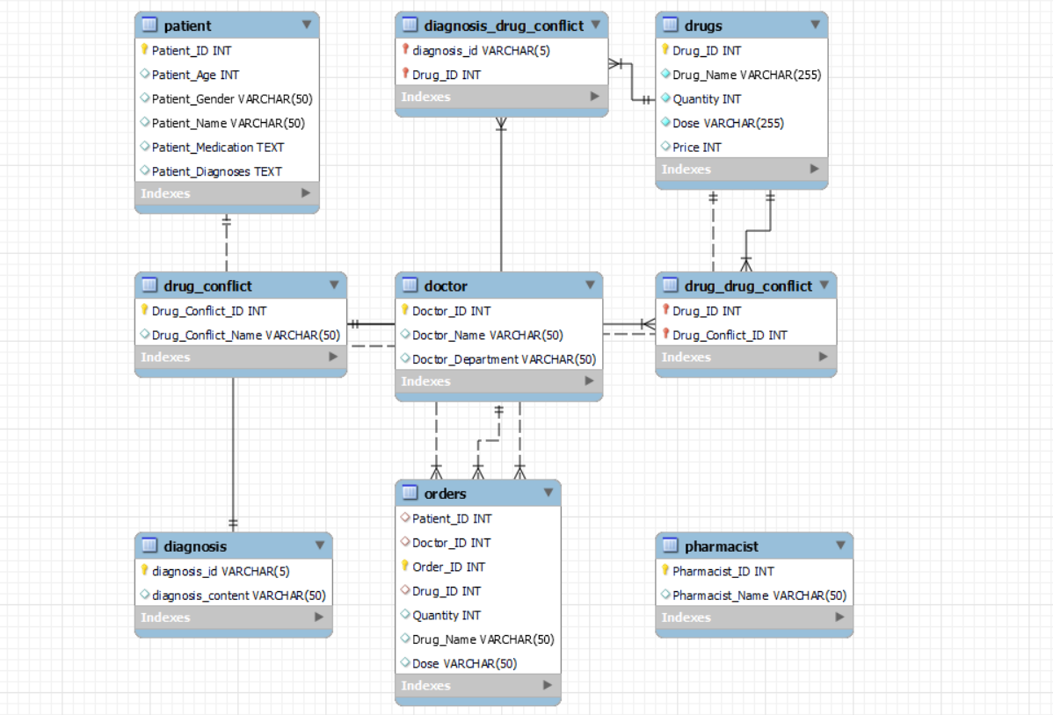

**Backend Database Implementation**

create database P;

use P ;

##########################################Entities##############################################################

#Doctors Data Doctors will be capable work with data of patients and see the drugs and choose it

create table doctor (

Doctor_ID INT primary key ,

Doctor_Name VARCHAR(50) ,

Doctor_Department VARCHAR(50)

);

INSERT INTO doctor (Doctor_ID, Doctor_Name, Doctor_Department) VALUES

(5511, 'Dr. Shaker Elsappagh', 'Cardiology'),

(5522, 'Dr. Radwa Hassan', 'General Surgery');

#patients that will be all operations done on themm

create table patient (

Patient_ID INT primary key ,

Patient_Age INT ,

Patient_Gender VARCHAR(50) ,

Patient_Name VARCHAR(50) ,

Patient_Medication TEXT ,

Patient_Diagnoses TEXT

);

INSERT INTO patient (Patient_ID, Patient_Name,Patient_Age,Patient_Gender, Patient_Medication, Patient_Diagnoses) VALUES

(511, 'Alice Brown',45,'Female','Data about Alice', 'Hypertension'),

(512, 'Bob Knight',55,'Male', 'Data about Bob', 'Diabetes'),

(513, 'Charlie Johnson',65,'Male', 'Data about Charlie', 'Asthma'),

(514, 'Diane Evans', 55,'Male','Data about Diane', 'Thyroid Disorder'),

(515, 'Edward Collins',71,'Male', 'Data about Edward', 'Arthritis');

#will be responsible for drug orders handling and manage inventory

CREATE TABLE pharmacist (

Pharmacist_ID INT PRIMARY KEY,

Pharmacist_Name VARCHAR(50)

);

INSERT INTO pharmacist (Pharmacist_ID, Pharmacist_Name) VALUES

(9911, 'Pharm John Doe'),

(9922, 'Pharm Jane Smith'),

(9933, 'Pharm Emily Stone'),

(9944, 'Pharm Mike Brown');

#Drugs table

CREATE TABLE IF NOT EXISTS drugs (

Drug_ID INT PRIMARY KEY,

Drug_Name VARCHAR(255) NOT NULL,

Quantity INT NOT NULL,

Dose VARCHAR(255) NOT NULL,

Price int

);

INSERT INTO drugs (Drug_ID,Drug_Name, Quantity, Dose,Price) VALUES (723,'Amoxicillin', 100, '10 mg',50);

INSERT INTO drugs (Drug_ID,Drug_Name, Quantity, Dose,Price) VALUES (855332,'Ciprofloxacin', 100, '200 mg',40);

INSERT INTO drugs (Drug_ID,Drug_Name, Quantity, Dose,Price) VALUES (115170,'Azithromycin', 100, '310 mg',57);

INSERT INTO drugs (Drug_ID,Drug_Name, Quantity, Dose,Price) VALUES (212121,'Sertraline', 100, '101 mg',32);

INSERT INTO drugs (Drug_ID,Drug_Name, Quantity, Dose,Price) VALUES (21227,'Fluoxetine', 100, '103 mg',76);

INSERT INTO drugs (Drug_ID,Drug_Name, Quantity, Dose,Price) VALUES (204299,'Citalopram', 100, '140 mg',89);

INSERT INTO drugs (Drug_ID,Drug_Name, Quantity, Dose,Price) VALUES (5640,'Ibuprofen', 100, '150 mg',67);

INSERT INTO drugs (Drug_ID,Drug_Name, Quantity, Dose,Price) VALUES (161,'Acetaminophen', 100, '120 mg',58);

INSERT INTO drugs (Drug_ID,Drug_Name, Quantity, Dose,Price) VALUES (1191,'Aspirin', 100, '130 mg',42);

INSERT INTO drugs (Drug_ID,Drug_Name, Quantity, Dose,Price) VALUES (29046,'Lisinopril', 100, '110 mg',45);

INSERT INTO drugs (Drug_ID,Drug_Name, Quantity, Dose,Price) VALUES (197361,'Amlodipine', 100, '110 mg',34);

INSERT INTO drugs (Drug_ID,Drug_Name, Quantity, Dose,Price) VALUES (897122,'Losartan', 100, '120 mg',52);

INSERT INTO drugs (Drug_ID,Drug_Name, Quantity, Dose,Price) VALUES (86009,'Metformin', 100, '120 mg',76);

INSERT INTO drugs (Drug_ID,Drug_Name, Quantity, Dose,Price) VALUES (197935,'Glibenclamide', 100, '190 mg',43);

INSERT INTO drugs (Drug_ID,Drug_Name, Quantity, Dose,Price) VALUES (897097,'Pioglitazone', 100, '300 mg',328);

#Drugs that may make conflict with each other

CREATE TABLE drug_conflict (

Drug_Conflict_ID INT PRIMARY KEY,

Drug_Conflict_Name VARCHAR(50)

);

INSERT INTO drug_conflict (Drug_Conflict_ID, Drug_Conflict_Name) VALUES (5640, 'Ibuprofen');

INSERT INTO drug_conflict (Drug_Conflict_ID, Drug_Conflict_Name) VALUES (1191, 'Aspirin');

INSERT INTO drug_conflict (Drug_Conflict_ID, Drug_Conflict_Name) VALUES (855332, 'Ciprofloxacin');

#relation that map each conflict with the drug

CREATE TABLE drug_drug_conflict (

Drug_ID INT,

Drug_Conflict_ID INT,

PRIMARY KEY (Drug_ID, Drug_Conflict_ID),

FOREIGN KEY (Drug_ID) REFERENCES drugs(Drug_ID),

FOREIGN KEY (Drug_Conflict_ID) REFERENCES drug_conflict(Drug_Conflict_ID)

);

INSERT INTO drug_drug_conflict (Drug_ID, Drug_Conflict_ID) VALUES

(855332, 5640),

(21227, 5640),

(212121, 1191),

(29046, 1191),

(86009, 855332),

(21227,855332);

#orders that eill made by doctor and sent to the pharmacist

CREATE TABLE orders (

Patient_ID INT,

Doctor_ID INT,

Order_ID INT AUTO_INCREMENT PRIMARY KEY,

Drug_ID INT,

Quantity INT,

Drug_Name VARCHAR(50),

Dose VARCHAR(50),

FOREIGN KEY (Drug_ID) REFERENCES drugs(Drug_ID),

FOREIGN KEY (Patient_ID) references patient(Patient_ID),

FOREIGN KEY (Doctor_ID) references doctor(Doctor_ID)

);

create table diagnosis (

diagnosis_id varchar(5) primary key ,

diagnosis_content varchar(50)

);

INSERT INTO diagnosis(diagnosis_id, diagnosis_content) VALUES ('I10', 'Hypertension (High Blood Pressure)');

INSERT INTO diagnosis(diagnosis_id, diagnosis_content) VALUES ('I25.10', 'Coronary Artery Disease');

INSERT INTO diagnosis(diagnosis_id, diagnosis_content) VALUES ('I50.9', 'Heart Failure');

INSERT INTO diagnosis(diagnosis_id, diagnosis_content) VALUES ('I48.91', 'Atrial Fibrillation');

INSERT INTO diagnosis(diagnosis_id, diagnosis_content) VALUES ('I21.9', 'Myocardial Infarction (Heart Attack)');

INSERT INTO diagnosis(diagnosis_id, diagnosis_content) VALUES ('I42.9', 'Cardiomyopathy');

INSERT INTO diagnosis(diagnosis_id, diagnosis_content) VALUES ('I35.0', 'Aortic Valve Stenosis');

INSERT INTO diagnosis(diagnosis_id, diagnosis_content) VALUES ('I73.9', 'Peripheral Artery Disease');

INSERT INTO diagnosis(diagnosis_id, diagnosis_content) VALUES ('I26.9', 'Pulmonary Embolism');

INSERT INTO diagnosis(diagnosis_id, diagnosis_content) VALUES ('I33.0', 'Endocarditis');

create table diagnosis_drug_conflict (

diagnosis_id varchar(5) ,

Drug_ID int ,

primary key(diagnosis_id,Drug_ID) ,

foreign key (diagnosis_id) references diagnosis(diagnosis_id),

foreign key (Drug_ID) references drugs(Drug_ID)

);

INSERT INTO diagnosis_drug_conflict(diagnosis_id,Drug_ID ) VALUES ('I50.9',1191);

INSERT INTO diagnosis_drug_conflict(diagnosis_id,Drug_ID ) VALUES ('I10', 5640);

**Frontend Design and Implementation**

Tkinter



Stremlit

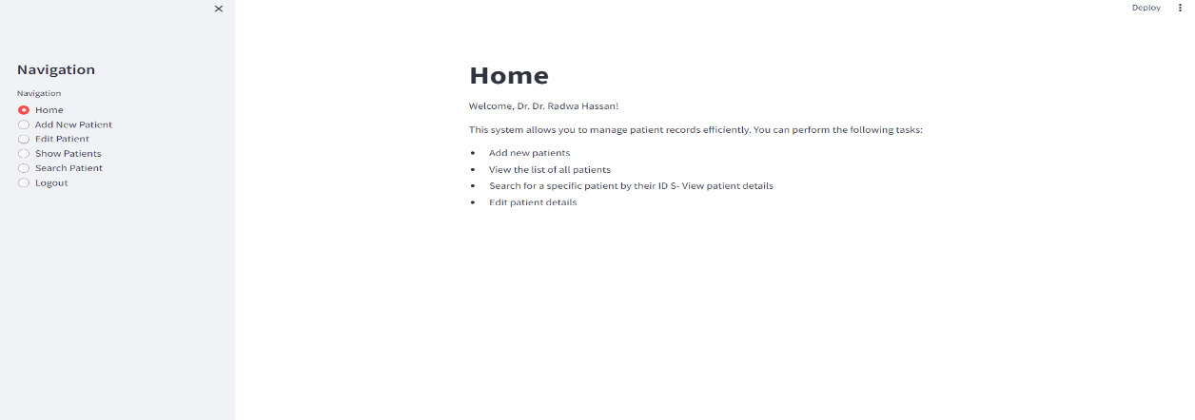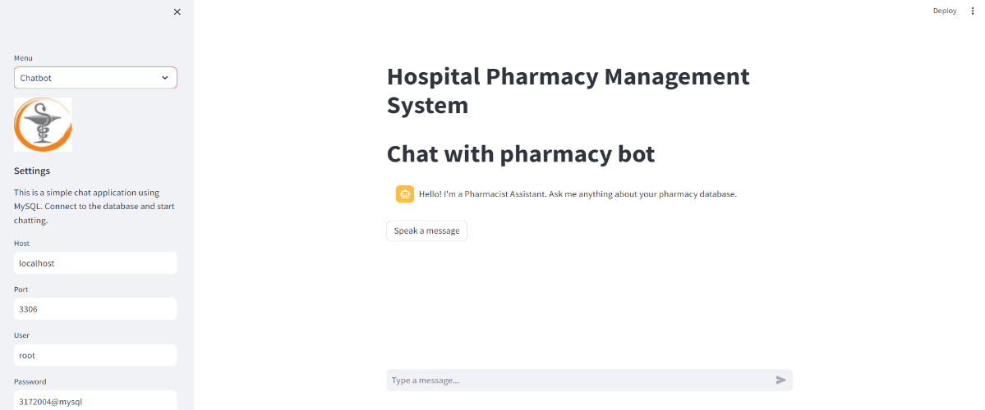

**https://drive.google.com/drive/folders/1cGWHMu85-FGhpUiJeXl7OqT1DSi11qdu?usp=sharing**

**Solved Challenges**

* Improve accuracy in medication dispensing.
* Enhance inventory management to prevent stockouts and overstocking.
* Streamline patient data management for better patient care and regulatory compliance.
* Chatbot to decrease load on the pharmacist
* Provide real-time data and reports for decision-making.
* Conflicts recognition

**Conclusion and Future Directions**

The HPMS successfully addressed the inefficiencies in hospital pharmacy management, providing a robust solution for medication dispensing, inventory control, and patient data management. Future enhancements could include integrating advanced analytics to predict medication demand, incorporating machine learning algorithms to identify potential medication errors, and expanding the system to support multi-hospital networks for centralized management.

**References**

Allen, D. E., & Goodwin, J. S. (2019). Optimizing hospital pharmacy workflows: A comprehensive review of system design and integration. Journal of Healthcare Engineering, 2019, Article ID 6234812. https://doi.org/10.1155/2019/6234812

Chan, B. Y., & Clark, L. M. (2018). Enhancing medication safety in hospitals: The role of pharmacy management systems. International Journal of Medical Informatics, 119, 43-49. https://doi.org/10.1016/j.ijmedinf.2018.09.002

Gallagher, J., & Cooper, J. W. (2020). Implementation of automated pharmacy systems in hospital settings: Challenges and solutions. American Journal of Health-System Pharmacy, 77(5), 331-339. https://doi.org/10.1093/ajhp/zxz306

Lee, S., & Johnson, J. A. (2021). Design and evaluation of a hospital pharmacy management system for inventory control. Health Information Management Journal, 50(2), 75-84. https://doi.org/10.1177/1833358320978161

Thompson, M. K., & Jones, A. R. (2017). Pharmacy information systems in hospital environments: Enhancing patient safety and operational efficiency. Healthcare Technology Letters, 4(3), 103-109. https://doi.org/10.1049/htl.2017.0002